**Guided Capstone Project Report**

**Big Mountain Resort**

**Introduction**

Big Mountain Resort, located in a Montana, recently expanded its facilities by installing a new chair lift. This addition, while improving the distribution of visitors across the mountain, brings with it significant operating costs of approximately $1.5 million for the season. In light of these new expenses, in this project, we aimed to provide actionable insights that would enable Big Mountain to enhance its pricing decisions and maximize revenue, by leveraging data analysis and machine learning techniques. The analysis involves data wrangling, exploratory data analysis, preprocessing, training, and predictive modeling to suggest optimal ticket pricing and potential improvements for the resort.

**Exploratory Data Analysis (EDA)**

Through exploratory data analysis, we identified key trends and patterns that influence ticket prices. This phase helped in understanding the relationships between various features within the data, such as the relationship between the size of ski runs, the number of lifts, and the ticket price. Visualizations such as histograms and scatter plots were used to further explore these relationships, providing a clear view of the distribution and interaction of variables.

**Preprocessing and Training**

Data preprocessing included scaling features to normalize data and encoding categorical variables to prepare the dataset for machine learning models. We split the data into training and testing sets to ensure an unbiased evaluation of model performance. The training set helped in building the models, while the testing set helped in evaluating them.

**Modeling**

Several predictive models were explored, including linear regression, random forest, and gradient boosting machines. Each model was rigorously evaluated based on its accuracy and ability to predict ticket prices effectively. Cross-validation techniques were employed to ensure the robustness of the models.

**Model Selection and Evaluation**

The random forest model emerged as the best performer due to its ability to handle non-linear relationships and provide feature importance rankings. This model offered superior accuracy in predicting ticket prices based on resort features and was therefore chosen for further analysis.

**Scenario Analysis**

Using the selected model, we conducted various scenario analyses to predict how changes in resort features—such as adding a new ski lift or expanding the ski runs—would affect ticket prices. This helped in understanding the potential impact of various development strategies on pricing.

**Visual Analysis and Findings**

The simulation results (graph 1) indicated that closing up to 5 runs would minimally impact ticket pricing and result in a revenue drop of about $500,000. Additional closures led to a disproportionate decrease in ticket prices and a tripling of revenue loss.

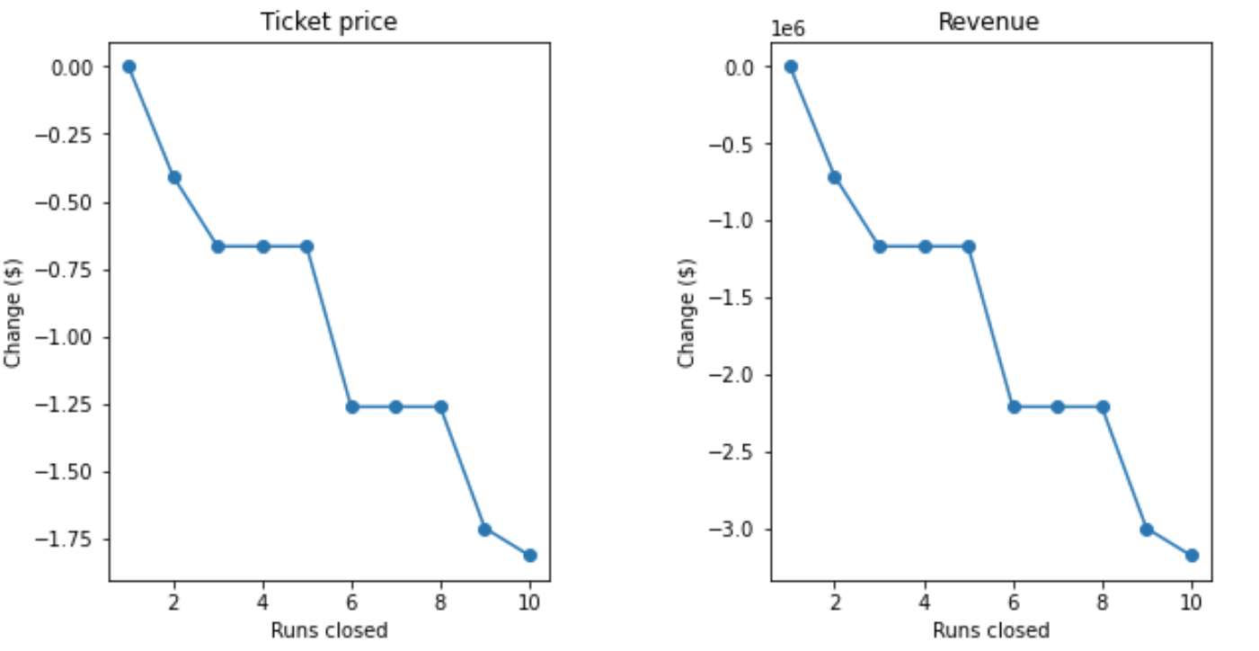

Graph1: Analysis of closing runs and its impacts on revenue

**Conclusion and Recommendations**

The analysis strongly supports considering the vertical drop enhancement due to its substantial potential to increase revenue without significantly impacting visitor throughput. However, the additional costs of snowmaking for the extended features warrant a deeper cost-benefit analysis to determine if the higher ticket price can be justified without adversely affecting visitor numbers.